|  |  |
| --- | --- |
| **WC Logo.emf** | **Staff Report to the Weber County Commission**  *Weber County Planning Division* |
|  | |

****Synopsis****

****Application Information****

**Application Request:** A public hearing to consider and take action on a request to vacate a 10-foot public utility easement located on the north and west side of Lot 2 of Drysdale Subdivision Phase 2

**Agenda Date: Tuesday, January 19, 2021**

**Applicant:** Kirk Nelson

**File Number:** EV2020-03

****Property Information****

**Approximate Address:** 4512 W 1800 S, Ogden Utah, 84401

**Project Area:** .92 Acres

**Zoning:** Agricultural (A-1)

**Existing Land Use:** Residential

**Proposed Land Use:** Residential

**Parcel ID:** 15-654-0001

**Township, Range, Section:** T6N, R2W, Section 20

****Adjacent Land Use****

**North:** Residential **South:** Residential

**East:** Residential **West:** Residential

****Staff Information****

**Report Presenter: Felix Lleverino**

flleverino@webercountyutah.gov

**801-399-8767**

**Report Reviewer:** SB

Development History

Drysdale Subdivision Phase 2 was recorded in the Weber County Recorder’s Office on March 15, 2018.

Background and Summary

The applicant has submitted a request to vacate a 10-foot public utility easement located on the north and west side of the lot. The property owner is requesting the vacation of the public utility easement in order to allow for the placement of an accessory structure. Weber County Planning Division has provided notice to Rocky Mountain Power, Taylor West Weber Water and Central Weber Sewer Improvement District in the form of an emailed notice to each entity representative.

The applicant has proposed to vacate the public utility easement by ordinance. Under Utah State Code, Section 17-27a-609.5, the legislative body may adopt an ordinance granting a petition to vacate some or all of a public street, right-of-way, or easement if the legislative body finds that:

(a) good cause exists for the vacation; and

(b) neither the public interest nor any person will be materially injured by the vacation.

The vacating procedure found in Utah State Code 17-27a-208 and 17-27a-209.5 do not require a Planning Commission recommendation.

The following is the staff's analysis of the vacation request.

Analysis

*General Plan*: Vacating this easement will not have a negative effect on the Western Weber General Plan.

*Additional Standards*: Utah State notice procedures (17-27a-208) have been followed for this petition to vacate. Any comments or objections to this proposal may be heard before or during a public hearing that is being held January 19th 2021.

*Agency Review*: The Weber County Engineering Department has requested that the owner gather approval letters from the remaining utility providers. Rocky Mountain Power, phone and cable companies, and water and sewer companies. When these letters are obtained, Engineering is ready to approve of this vacation. Planning is bringing this before the approval body in anticipation of gathering all applicable letters that would satisfy this requirement. The ordinance will not be recorded until the County Engineering has approved of it.

State Public Noticing Requirements have been met as outlined in.

Staff Recommendation

Staff recommends approval of the request to vacate a 10-foot public utility easement located on the north and west side of Lot 2 of Drysdale Subdivision Phase 2. This recommendation for approval is subject to all review agency requirements and is based on the following condition:

1. Rocky Mountain Power, Dominion Energy, Taylor West Weber Water and Central Weber Sewer Improvement District provide proof that they release their interest in the north public utility easement before recording the ordinance to vacate the public utility easement.
2. The ordinance to vacate the public utility easement will be recorded.

This recommendation for approval is based on the following findings:

1. Vacating the proposed easement does not conflict with the Western Weber General Plan.
2. The public interest or any person will not be materially injured by the proposed vacation.
3. The proposed vacation will not be detrimental to the public health, safety, or welfare.
4. The proposed vacation will not deteriorate the environment of the general area to negatively impact surrounding properties and uses.

Exhibits

1. Drysdale Subdivision Plat
2. Proposed areas to be vacated
3. Vacation Application
4. Vacation ordinance**11kfjf**

Area Map

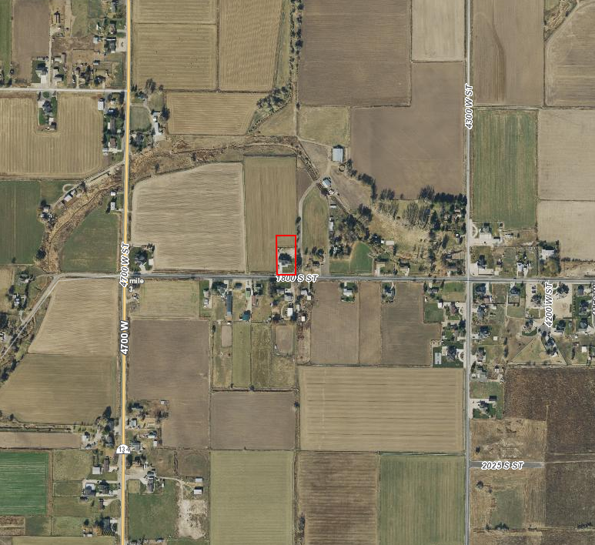

Exhibit A

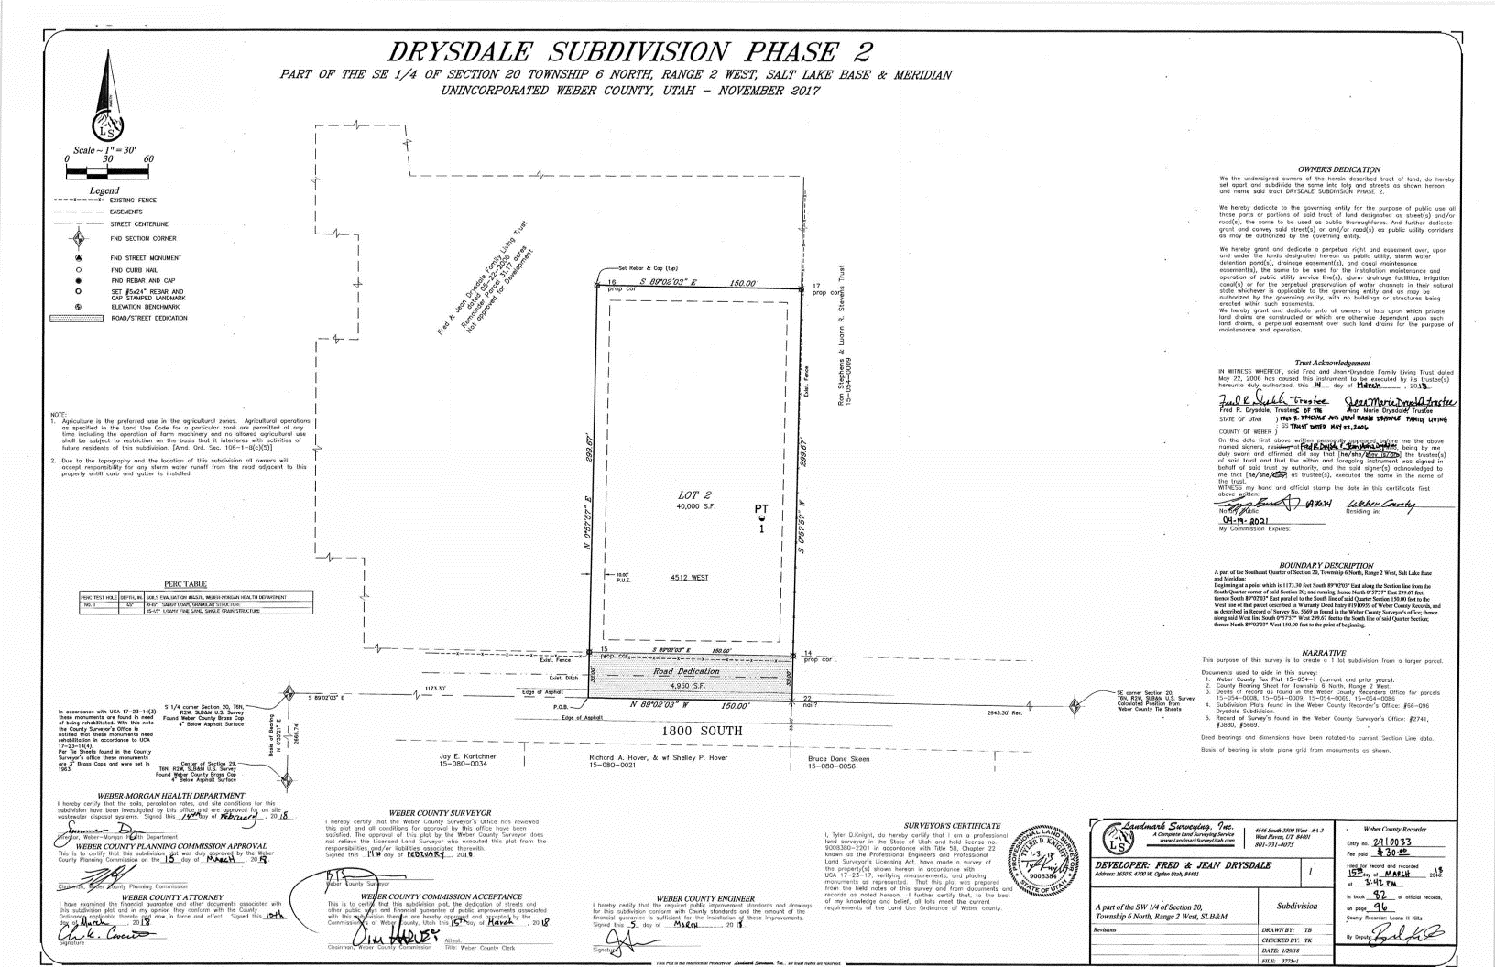

Exhibit B

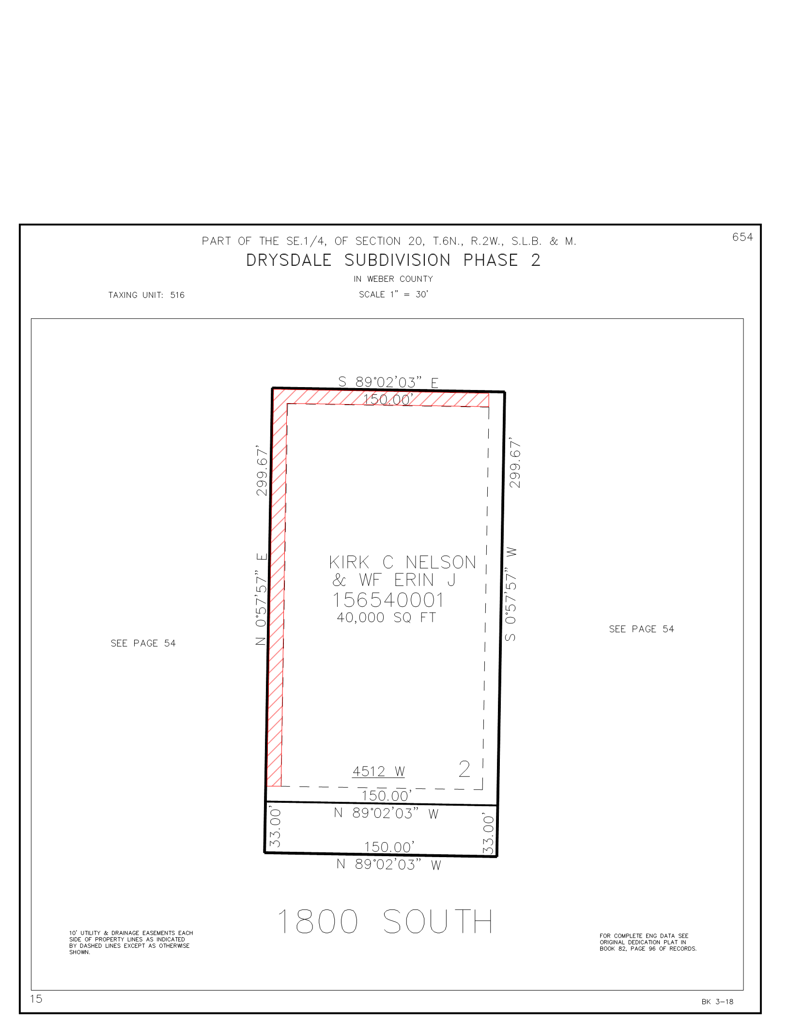

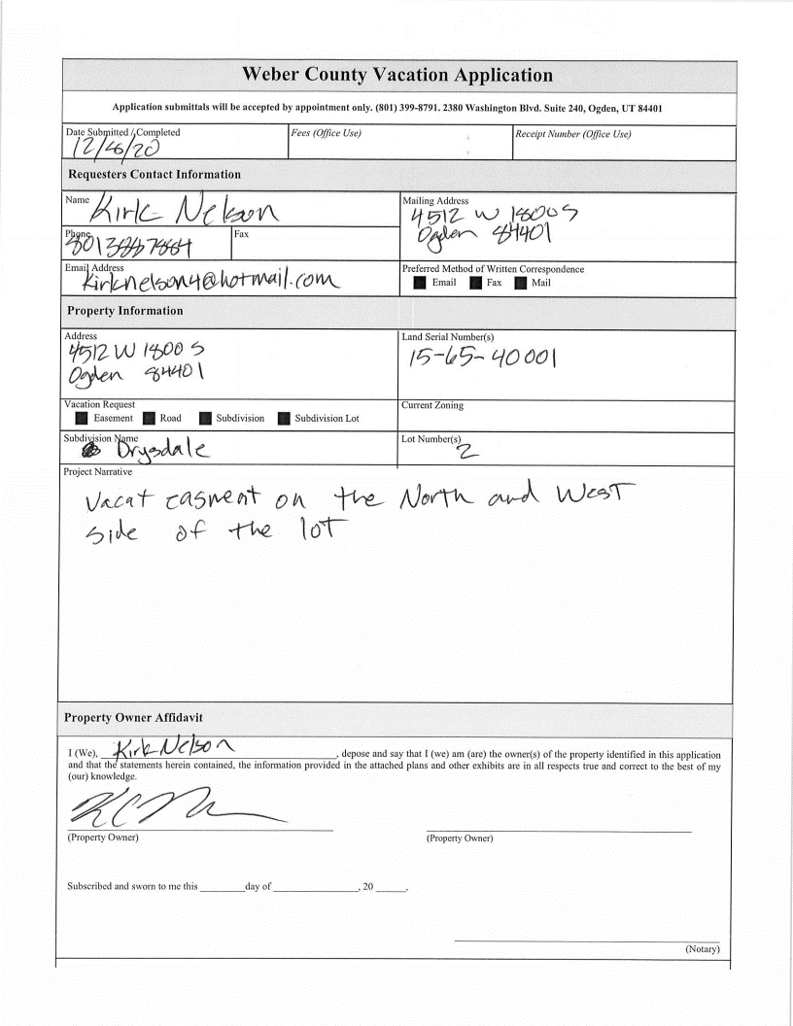Exhibit C

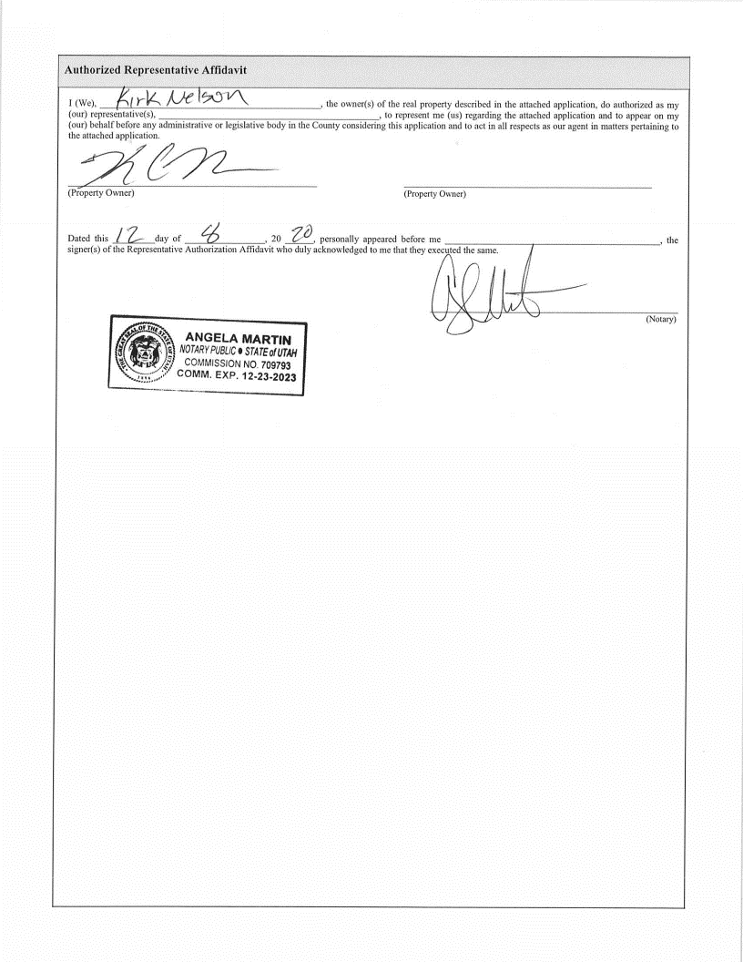

Exhibit D

**Ordinance**

**AN ORDINANCE OF THE BOARD OF COUNTY COMMISSIONERS OF WEBER COUNTY VACATING A TEN FOOT PUBLIC UTILITY EASEMENT ON LOT 2 OF THE DRYSDALE SUBDIVISION PHASE 2**

**WHEREAS,** Kirk Nelson, the legal lot owner of Lot 2 of the Drysdale Subdivision Phase 2, has filed a petition to vacate the north and west 10-foot public utility easement located within Lot 2 of the Drysdale Subdivision Phase 2; and

**WHEREAS,** the residential lot 2 is described in a plat named “Drysdale Subdivision Phase 2,” recorded in the Weber County Recorder’s Office on March 15, 2018, as Entry number 2910033; and

**WHEREAS,** after providing proper public notice, a public hearing was held on January 16, 2021, regarding the vacation of the north and west 10-foot public utility easement located within Lot 2 of the Drysdale Subdivision Phase 2; and

**WHEREAS,** The Weber County Engineering Department has been notified and has provided written approval of the vacation of the public utility easement located within Lot 2 of the Drysdale Subdivision Phase 2; and

**WHEREAS,** the Board of County Commissioners finds that the vacation of the public utility easement within Lot 2 of the Drysdale Subdivision Phase 2 will not substantially affect the West Central Weber County General Plan or the health, safety, and welfare of the general public;

**NOW THEREFORE,** the Board of County Commissioners of Weber County ordains as follows: The following public utility easement located within Lot 2 of the Drysdale Subdivision Phase 2, which is described in Entry number 2910033 of the Weber County Recorder’s Office, is hereby vacated from the subdivision:

**The north and west 10-foot public utility easement located within Lot 2 of the Drysdale Subdivision Phase 2, as highlighted with cross hatches on the 2020 Recorder’s plat (15-654) (Exhibit A), is hereby vacated from said lot.**

**This Ordinance shall be effective 15 days after publication in the Standard Examiner.**

Passed, adopted, and ordered published this day of , 2021, by the Board of County Commissioners of Weber County.

(*signatures on following page*)

BOARD OF COUNTY COMMISSIONERS OF WEBER COUNTY

By___________________________________

Gage Froerer, Chair

Commissioner Froerer Voting

Commissioner Harvey Voting

Commissioner Jenkins Voting

ATTEST:

Ricky Hatch, CPA

Weber County Clerk

EXHIBIT A

